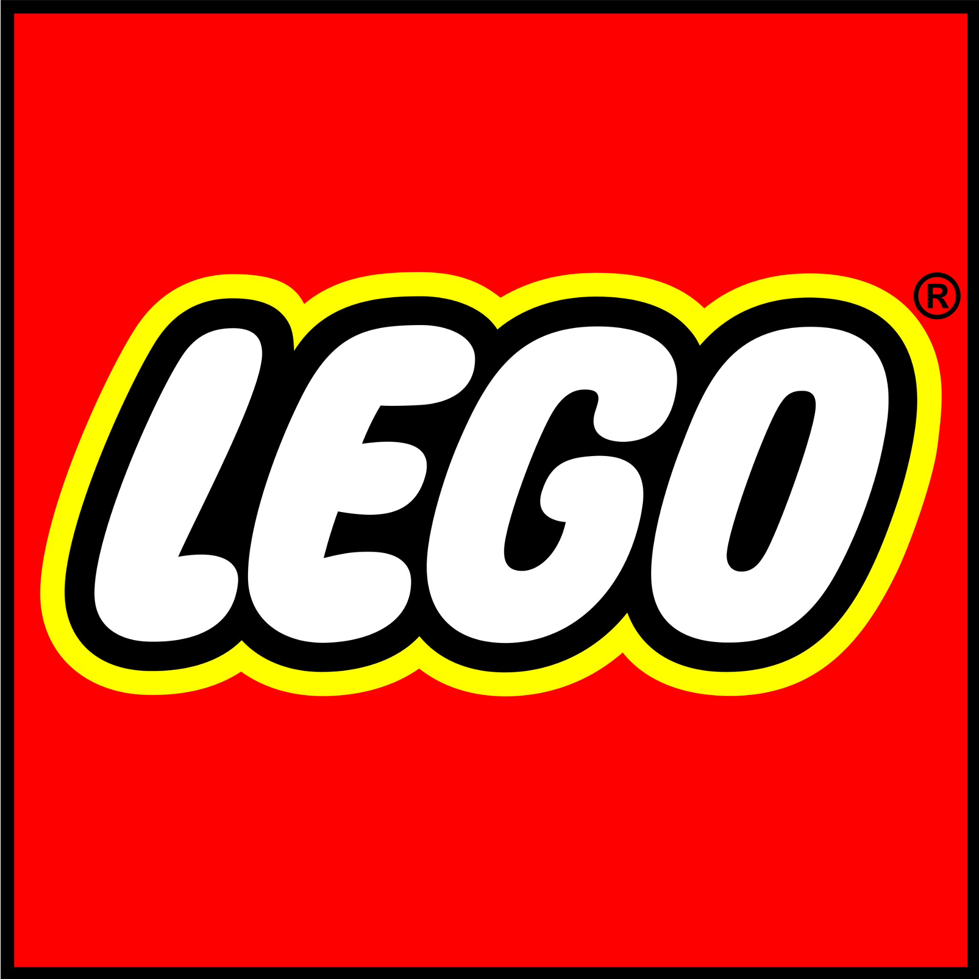

***The Hourglass (or The Yeti)***

May, 2021

**Overview**

The purpose of this report is to identify opportunities for content creators to diversify character representations. This report measures representations of six identities in the script *The Hourglass* for LEGO Titan:

* Gender
* Race/Ethnicity
* LGBTQ+
* Disability
* Age (50+)
* Body Size

**Methodology**

Spellcheck for Bias is based on inventions and software developed at the USC Viterbi School of Engineering. For this report, we analyze characters who spoke 1 line of text or more. In *The Hourglass*, 9 characters met this criterion:

| **CHARACTER NAME** | **LINE COUNT** |
| --- | --- |
| IZZIE | 68 |
| LOGAN | 57 |
| MATEO | 56 |
| OZ | 51 |
| YETI | 36 |
| COOP | 35 |
| DARK ARCHER | 13 |
| NIGHTMARE KING | 10 |
| ALBERT | 2 |

Automated coding is combined with expert human coding to generate the quantitative and qualitative analysis below.

**Gender Analysis**

***For comparison, women constitute 51% of the U.S. population.***

* 11% of characters are specified as female.
* The leading character is male (Mateo).
* The script contains 0 character opportunities to increase gender diversity.

Characters by Gender

| **FEMALE CHARACTER** | **MALE CHARACTER** | **GENDER UNSPECIFIED** |
| --- | --- | --- |
| IZZIE | IZZIE |  |
|  | LOGAN |  |
|  | MATEO |  |
|  | OZ |  |
|  | YETI |  |
|  | COOP |  |
|  | DARK ARCHER |  |
|  | NIGHTMARE KING |  |
|  | ALBERT |  |

The See Jane Test

| **In order to pass the See Jane test, a script/manuscript must have:** | |
| --- | --- |
| **YES** | At least one prominent character (leading, co-leading, supporting character) who is a woman who; |
| **NO** | Is not depicted with gender stereotypes or tropes. |



**Race/Ethnicity Analysis**

***For comparison, people of color constitute 38% of the U.S. population.***

* 43% characters are specified as characters of color.
* The leading character is a character of color (Mateo).
* The script contains 2 character opportunities to increase racial/ethnic diversity.

Characters by Race/Ethnicity

| **CHARACTER OF COLOR** | **WHITE CHARACTER** | **RACE/ETHNICITY UNSPECIFIED** |
| --- | --- | --- |
| IZZIE |  |  |
| LOGAN |  |  |
| MATEO |  |  |
|  | OZ |  |
|  |  | (YETI)* |
|  | COOP |  |
|  |  | DARK ARCHER |
|  |  | NIGHTMARE KING |
|  |  | (ALBERT) |

*Non-human characters are in parentheses and we do not include these characters when assessing this dimension or calculating representation.

The Shonda Rhimes Test

| **In order to pass the Shonda Rhimes test, a script/manuscript must have:** | |
| --- | --- |
| **YES** | At least one prominent character (leading, co-leading, supporting character) who is a character of color who; |
| **YES** | Is not depicted with race/ethnicity stereotypes or tropes. |



**LGBTQ+ Analysis**

***For comparison, LGBTQ+ people comprise 4.5% of the U.S. population.***

* 0 characters are specified as LGBTQ+.
* The leading character is specified as heterosexual (Mateo).
* The script contains 7 character opportunities to increase LGBTQ+ diversity.

Characters by LGBTQ+ Status

| **LGBTQ+ CHARACTER** | **HETEROSEXUAL CHARACTER** | **SEXUALITY UNSPECIFIED** |
| --- | --- | --- |
|  |  | IZZIE |
|  | LOGAN | LOGAN |
|  | MATEO | MATEO |
|  |  | OZ |
|  |  | YETI |
|  |  | COOP |
|  |  | DARK ARCHER |
|  |  | NIGHTMARE KING |
|  |  | ALBERT |

The Vito-Russo Test

| **In order to pass the Vito-Russo test, a script/manuscript must:** | |
| --- | --- |
| **NO** | Contain a character that is identifiably lesbian, gay, bisexual, transgender, and/or queer. |
|  | That character must not be solely or predominantly defined by their sexual orientation or gender identity (i.e. they are comprised of the same sort of unique character traits commonly used to differentiate straight/non-transgender characters from one another). |
|  | The LGBTQ character must be tied into the plot in such a way that their removal would have a significant effect, meaning they are not there to simply provide colorful commentary, paint urban authenticity, or (perhaps most commonly) set up a punchline. |



**Disability Analysis**

***For comparison, people with disabilities constitute 19% of the U.S. population.***

* 0 characters are specified as having a physical, cognitive, or communication disability.
* The leading character has an unspecified disability status (Mateo).
* The script contains 9 character opportunities to increase disability diversity.

Characters by Disability Status

| **CHARACTER WITH DISABILITY** | **CHARACTER WITHOUT DISABILITY** | **DISABILITY STATUS UNSPECIFIED** |
| --- | --- | --- |
|  |  | IZZIE |
|  |  | LOGAN |
|  |  | MATEO |
|  |  | OZ |
|  |  | YETI |
|  |  | COOP |
|  |  | DARK ARCHER |
|  |  | NIGHTMARE KING |
|  |  | ALBERT |

The Marlee Matlin Test

| **In order to pass the Marlee Matlin test, a script/manuscript must have:** | |
| --- | --- |
| **NO** | At least one prominent character (leading, co-leading, supporting character) with a physical, cognitive, or communication disability who; |
|  | Is not depicted with disability stereotypes or tropes. |



**Age (50+) Analysis**

***For comparison, people ages 50+ constitute 34% of the U.S. population.***

* 22% characters are specified as ages 50+.
* The leading character is under 50 (Mateo).
* The script contains 2 character opportunities to increase age diversity.

Characters by Age

| **CHARACTER 50+** | **CHARACTER UNDER 50** | **AGE UNSPECIFIED** |
| --- | --- | --- |
|  | IZZIE |  |
|  | LOGAN |  |
|  | MATEO |  |
| OZ |  |  |
|  |  | YETI |
|  | COOP |  |
|  | DARK ARCHER | DARK ARCHER |
|  |  | NIGHTMARE KING |
| ALBERT |  | ALBERT |

The Betty White Test

| **In order to pass the Betty White test, a script/manuscript must have:** | |
| --- | --- |
| **YES** | At least one prominent character (leading, co-leading, supporting character) who is 50+ who; |
| **YES** | Is not depicted with age stereotypes or tropes. |



**Body Size Analysis**

***For comparison, people with large body types constitute 39% of the U.S. population.***

* 0 characters are specified as having a large body type.
* The leading character has an unspecified body type (Mateo). .
* The script contains 9 character opportunities to increase body type diversity.

Characters by Body Size

| **CHARACTER WITH LARGE BODY TYPE** | **CHARACTER WITH SMALL/MEDIUM BODY TYPE** | **BODY SIZE UNSPECIFIED** |
| --- | --- | --- |
|  |  | IZZIE |
|  |  | LOGAN |
|  |  | MATEO |
|  |  | OZ |
|  |  | YETI |
|  |  | COOP |
|  |  | DARK ARCHER |
|  |  | NIGHTMARE KING |
|  |  | ALBERT |

The Lizzo Test

| **In order to pass the Lizzo test, a script/manuscript must have:** | |
| --- | --- |
| **NO** | At least one prominent character (leading, co-leading, supporting character) with a large body type who; |
|  | Is not depicted with size stereotypes or tropes. |



**Intersectional Analysis**

|  | **Female Character** | **Character of Color** | **LGBTQ+ Character** | **Character with a Disability** | **Character 50+** | **Character with Large Body Type** |
| --- | --- | --- | --- | --- | --- | --- |
| **Female Character** |  | **YES** | **NO** | **NO** | **NO** | **NO** |
| **Character of Color** | **YES** |  | **NO** | **NO** | **NO** | **NO** |
| **LGBTQ+ Character** | **NO** | **NO** |  | **NO** | **NO** | **NO** |
| **Character with a Disability** | **NO** | **NO** | **NO** |  | **NO** | **NO** |
| **Character 50+** | **NO** | **NO** | **NO** | **NO** |  | **NO** |
| **Character with Large Body Type** | **NO** | **NO** | **NO** | **NO** | **NO** |  |

**Positive Aspects**

* Healthy masculinity: Male character (Yeti) gets a beauty makeover and enjoys it.
* Destigmatizes failure and encourages getting help: Mateo (male character) fails multiple times when trying to jump over hurdles. He nevertheless continues to try and eventually becomes successful after getting help from Logan.
* Healthy masculinity: Logan helps Mateo learn how to jump over hurdles.
* Several characters of color (particularly male characters of color) are engaging in creative activities.

**Potential Pitfalls**

* Potential Sexism:
  + Potential gendering of creativity: Izzie’s creativity is manifested in gender-stereotypical ways (glamorous “monster makeovers” and asking to add glitter to various things). Cooper’s creativity also conforms to gender-stereotypes, particularly when he dreams up a “primitive truck” when racing Logan.
  + Izzie is rescued by male characters, a gender-based stereotype and plot point.
  + The cool sports team is associated with hyper-masculinity (Logan, who is talented at sports, demeans others and is hyper-competitive; sports tryouts are called “Sheep Week” [slaughter of the weak sheep by wolves - the team name]).
  + Logan is written with the gender-based “reckless male” and “alpha male” stereotypes.
  + All “evil villains” in the script are male, and written with the gender-based “violent-male” trope.
* Potential Racism:
  + As mentioned in previous analysis, palette choices and name of the villains may contribute to children associating ‘ugliness’ and ‘darker colors’ with ‘evil,’ and pretty things that are ‘lighter’ with ‘good’.
* Potential Ableism: consider replacing ableist language (“stupid”; “crazy”; “dum dums”) with neutral language (e.g., “silly”, “chaotic”, “wonderful”). Not only is utilizing alternative words more inclusive, it can serve to expand children’s vocabulary and encourage children to be more creative with their language choice when describing events.